Guide: How to create a card in planner

This guide will walk you through the process of creating a card on a Planner. Follow the steps below to ensure your card is properly set up and organized.

**Step 1: Access the Planner**

Click [here](https://tasks.office.com/deakin365.onmicrosoft.com/en-AU/Home/Planner/#/plantaskboard?groupId=a3977aab-e4c1-4a33-8fd8-b0e7f10b979c&planId=NIxLve7-y0CigNFNSZKHmsgABna4) to open the planner application in your web browser, you will then see the planner opened as below.

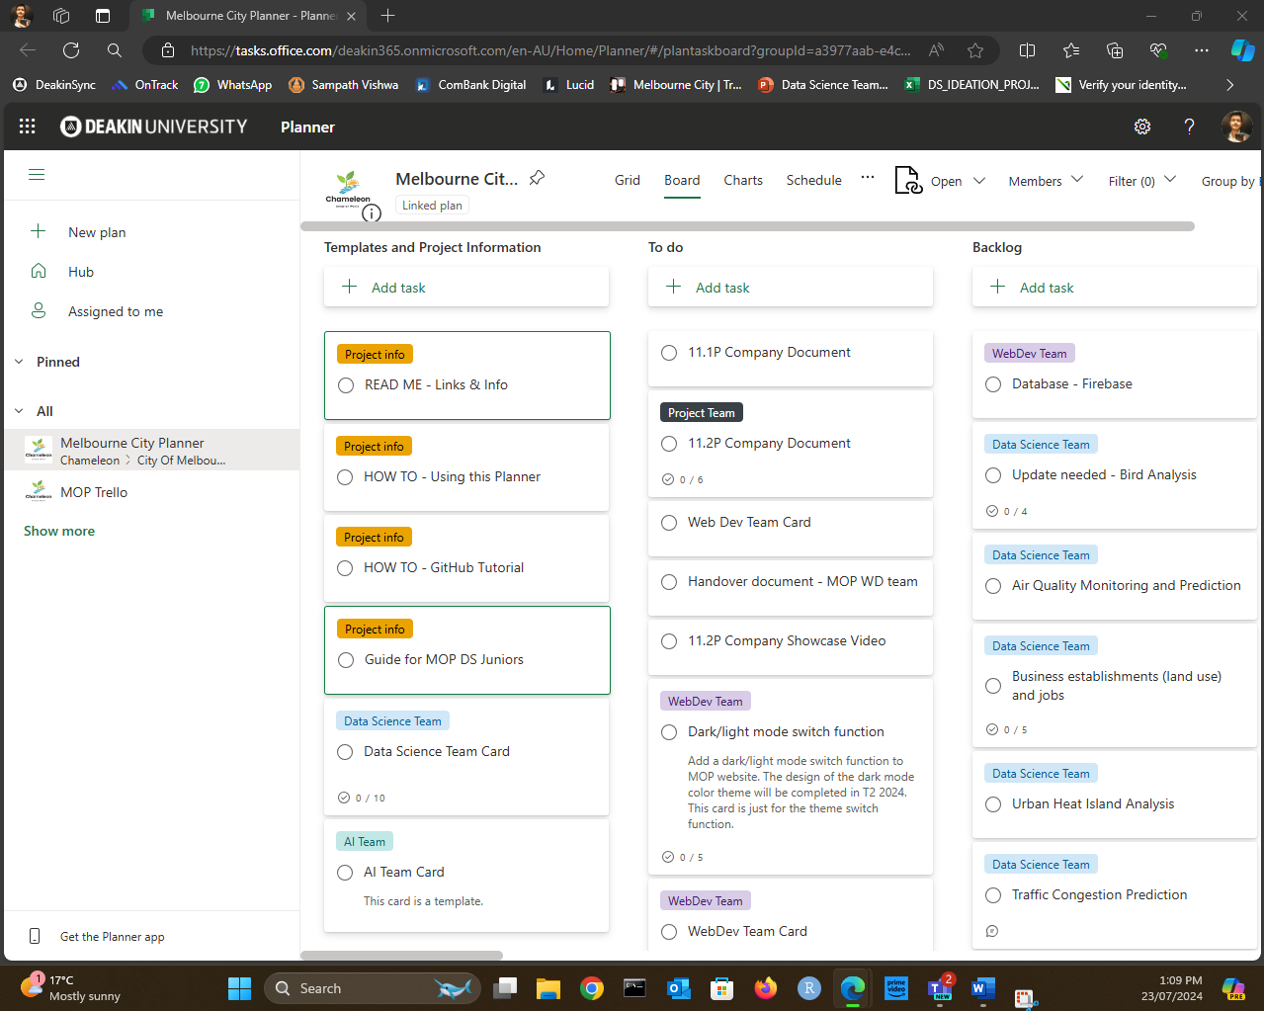

**Step 2: Select the Appropriate Plan**

As shown in the below figure make sure you in the **Melbourne City Planner**.

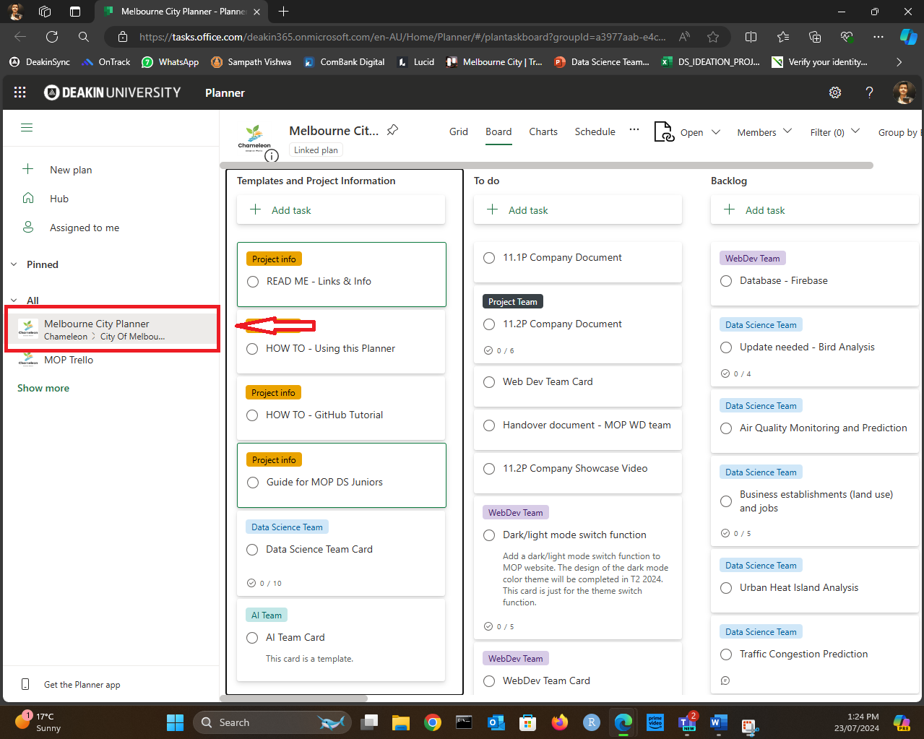

**Step 3: Copy the Template**

* Go to the bucket **Template and Project information**
* Click on the three dots (ellipsis) on the right side of the **template card**.
* Select "Copy Task" from the **dropdown menu**.

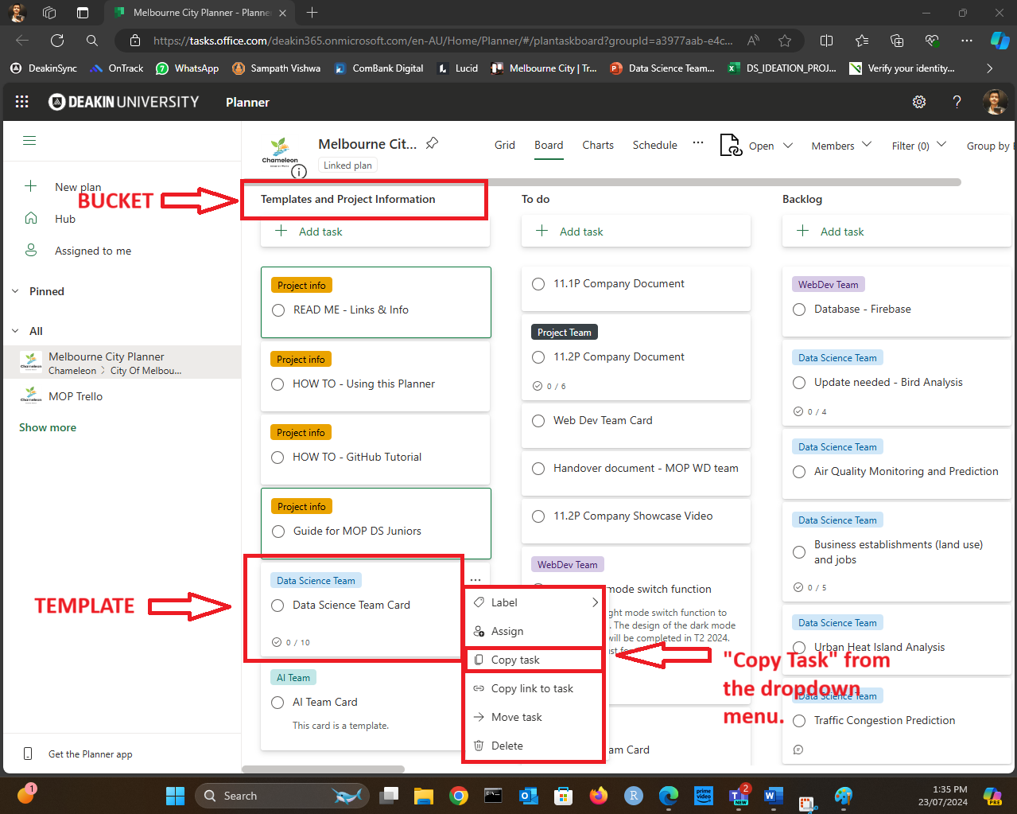

**Step 4: Configure the New Card**

1. A pop-up window for the new card will appear.
2. Rename the card by entering a new title in the provided field. For new use cases please make sure to start the title by mentioning as **New Use Case** – Following up with the use case title
3. Select the appropriate Planner from the dropdown menu. (keep the default **Melbourne City Planner**)
4. Choose the bucket where the card should be placed.

* If no one is working on the use case, put it in the **Backlog** bucket
* Or if you are working on it, put it to the **Sprint 1 (Week 3,4,5) T2 2024** bucket

1. Then click copy and create the card.
   * After that the card will appear in appropriate bucket. (in this case it will be in the **Sprint 1 (Week 3,4,5) T2 2024** bucket)

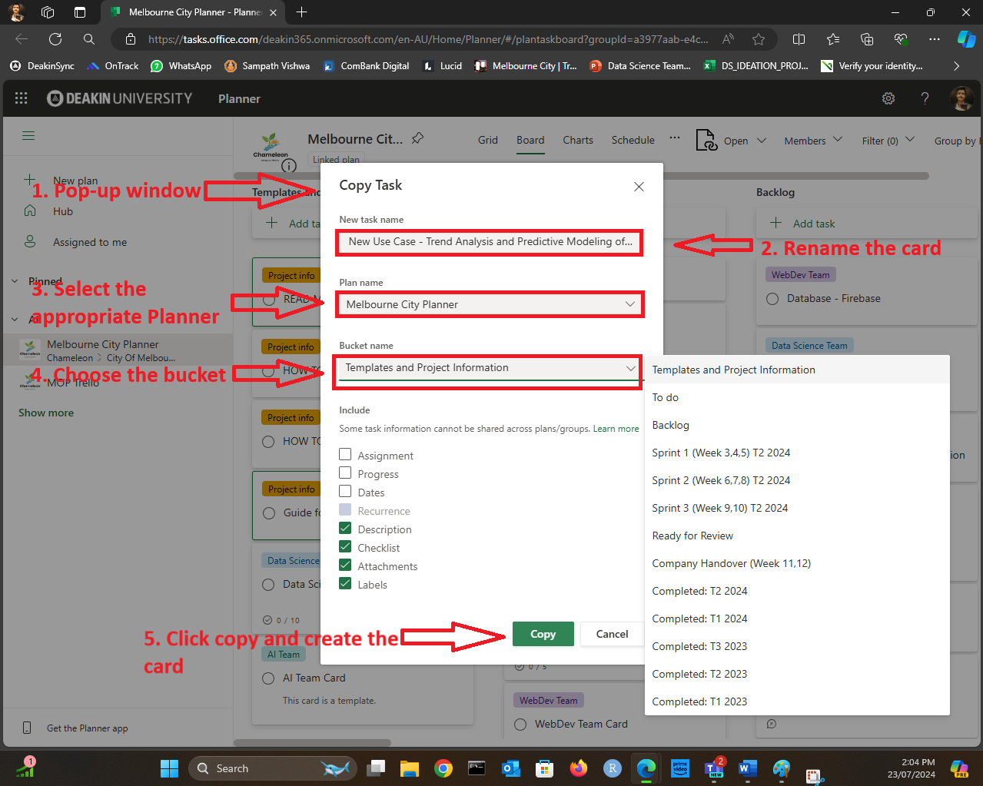

**Step 4: Add Task Information**

Go to appropriate bucket and select the created card

1. **Labels:** Select or create labels to categorize your card.
2. **Progress Status:** This is the section where you can see the current progress of the task. In the image, it is marked as "In progress." **Note:** Please do not set it to "Completed." Instead, update your checklist because if you mark it as complete, it will disappear from the planner. It is strongly recommended to keep it "In progress" or not to touch it.
3. **Notes:** In the notes section, first indicate the focus area of your use case **(Business Activity,** **Environment & Wellbeing,** or **Transport & Safety).** Then, include the links to the data sets (you can find them in the Project [IDEATION](https://deakin365.sharepoint.com/:x:/s/Chameleon2/ETSOxoKEBcVDivuTJxhX_dsBJ7Ck7a3yrTvxeku9na9CYQ?e=qb8kLl&ovuser=d02378ec-1688-46d5-8540-1c28b5f470f6%2Cs223270464%40deakin.edu.au&clickparams=eyJBcHBOYW1lIjoiVGVhbXMtRGVza3RvcCIsIkFwcFZlcnNpb24iOiI0OS8yNDA2MTMxODQxMyIsIkhhc0ZlZGVyYXRlZFVzZXIiOmZhbHNlfQ%3D%3D&wdLOR=c035E85D2-0D0F-48C0-A3DE-C3298946340C) list). Finally, provide a description of the use case.
4. **Show on Card Option:** This is a checkbox option labeled "Show on card," which allows you to choose whether to display the detailed information on the card overview.

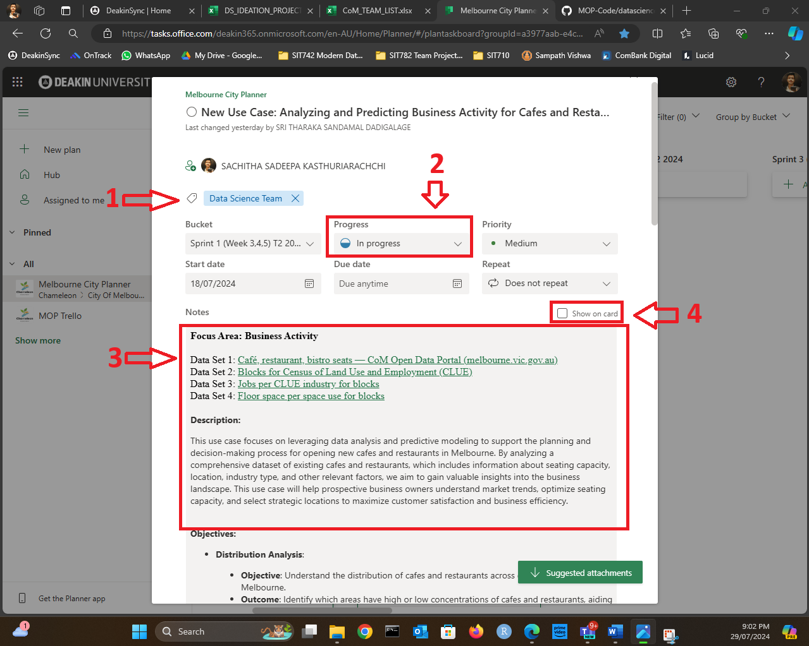

1. **Checklist:** Add the necessary steps by entering each item and pressing Enter.
2. **Attachments:** Click on "Add attachment" to upload files or add links.

**Step 5: Assigning Team Members to Active Tasks**

**Ensure Active Tasks Have Assigned Users**

1. **Assign Members**:

* Open the task card that is in progress.
* Click on the "Assign" button.
* Select the team members who will be working on this task.

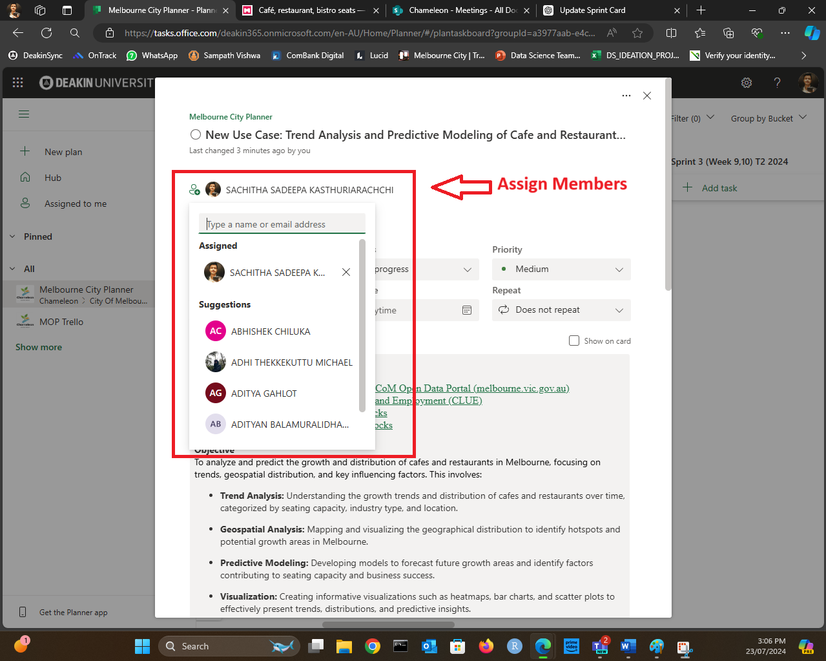

**Tips for Effective Task Management**

* **Regular Updates**: Update the status of the card as the task progresses.
* **Communication**: Use the comments section within the card to communicate with team members.
* **Deadlines and Reminders**: Set due dates and reminders to keep tasks on track.
* **Review**: Regularly review all active and backlog tasks to ensure proper assignment and progress

**Conclusion**

By following these steps, you can efficiently create and manage tasks on Planner, ensuring that all tasks are properly documented and assigned. Regular updates and communication will help maintain a productive workflow.

## Author

Sachitha 2024.v1